Short Library Website
A very short library page (about 30 lines). It lets you search books by title or author, log in by name, borrow available books, and shows issued books with the fine (Rs 2 per day after 14 days) and a return button.
Note: data resets when the page is reloaded.

Output
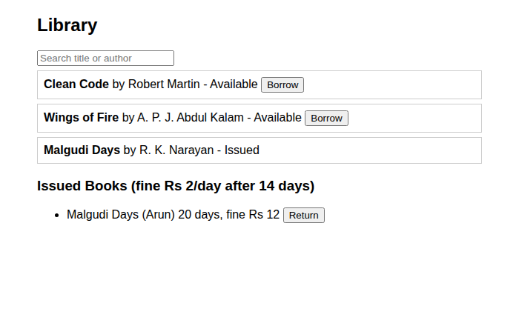
Figure 1: Book list with search and issued books (overdue fine shown)
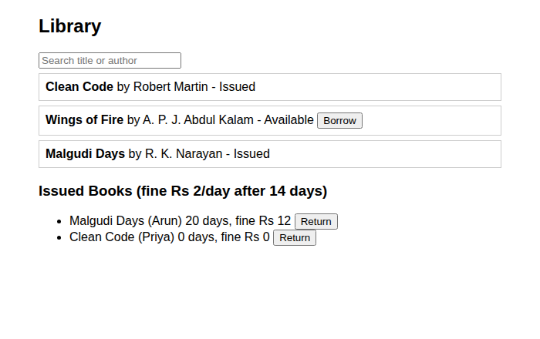
Figure 2: After borrowing a book, it appears under Issued Books

Code (library_short.html)
<!DOCTYPE html>
<html><head><title>Library</title>
<style>body{font-family:Arial;max-width:600px;margin:20px auto}.b{border:1px solid #ccc;padding:8px;margin:6px 0}</style></head>
<body>
<h2>Library</h2>
<input id="q" placeholder="Search title or author" oninput="show()">
<div id="list"></div>
<h3>Issued Books (fine Rs 2/day after 14 days)</h3><ul id="my"></ul>
<script>
var user = "";
var books = [{ t: "Clean Code", a: "Robert Martin", in: true }, { t: "Wings of Fire", a: "A. P. J. Abdul Kalam", in: true },
{ t: "Malgudi Days", a: "R. K. Narayan", in: false }];
var issued = [{ t: "Malgudi Days", who: "Arun", days: 20 }];
function fine(s) { return Math.max(0, s.days - 14) * 2; }
function show() {
list.innerHTML = books.map(function (x, k) {
if ((x.t + x.a).toLowerCase().indexOf(q.value.toLowerCase()) < 0) return "";
return "<div class='b'><b>" + x.t + "</b> by " + x.a + " - " + (x.in ? "Available <button onclick='borrow(" + k + ")'>Borrow</button>" : "Issued") + "</div>";
}).join("");
my.innerHTML = issued.map(function (s, i) {
return "<li>" + s.t + " (" + s.who + ") " + s.days + " days, fine Rs " + fine(s) + " <button onclick='giveBack(" + i + ")'>Return</button></li>"; }).join("");
}
function borrow(k) {
user = user || prompt("Login: enter your name");
if (user) { books[k].in = false; issued.push({ t: books[k].t, who: user, days: 0 }); show(); }
}
function giveBack(i) {
alert("Returned. Fine: Rs " + fine(issued[i]));
books.forEach(function (b) { if (b.t == issued[i].t) b.in = true; });
issued.splice(i, 1); show();
}
show();
</script></body></html>

